Task 1

**Do a write up for the followings:**

1. **Difference between HTTP1.1 vs HTTP2 HTTP version history**
2. **List 5 differences between Browser JS vs Node Js.**
3. **what happens when you type a URL in the address bar in the browser?**

**Task 2**

1. **html and script.js file and run a for loop on the data and print all the country names in the console.**
2. **Write a write up on Difference between copy by value and copy by reference.**
3. **How to copy by value a composite data type (array+objects).**
4. **JSON task https://medium.com/@reach2arunprakash/guvi-zen-code-sprint-javascript-practice-problems-in-json-objects-and-list-49ac3356a8a5 Try the rest countries api.**
5. **Extract and print the total population of all the countries in the console. use the html template. https://restcountries.eu/rest/v2/all**
6. **HTTP 1.1 vs HTTP 2**

The HTTP/2 protocol has several prime differences from the HTTP/1.1 version:

* It is a binary protocol rather than text. It can no longer be read and created manually. Despite this hurdle, improved optimization techniques can now be implemented.
* It is a multiplexed protocol. Parallel requests can be handled over the same connection, removing the order and blocking constraints of the HTTP/1.x protocol.
* It compresses headers. As these are often similar among a set of requests, this removes duplication and overhead of data transmitted.
* It allows a server to populate data in a client cache, in advance of it being required, through a mechanism called the server push.

**2. Difference between BrowserJS and Node JS**

1. Javascript is a programming language that is used for writing scripts on the website. NodeJS is a Javascript runtime environment.
2. Javascript can only be run in the browsers.NodeJS code can be run outside the browser.
3. It is basically used on the client-side.It is mostly used on the server-side.
4. Javascript is capable enough to add HTML and play with the DOM.Nodejs does not have capability to add HTML tags.
5. Javascript can run in any browser engine as like JS core in safari and Spidermonkey in Firefox.Nodejs can only run in V8 engine of google chrome.

**3. what happens when you type a URL in the address bar in the browser?**

1. You enter a URL into a web browser
2. The browser looks up the IP address for the domain name via DNS
3. The browser sends a HTTP request to the server
4. The server sends back a HTTP response
5. The browser begins rendering the HTML
6. The browser sends requests for additional objects embedded in HTML (images, css, JavaScript) and repeats steps 3-5.
7. Once the page is loaded, the browser sends further async requests as needed.

**Task 2**

1. **html and script.js file and run a for loop on the data and print all the country names in the console.**

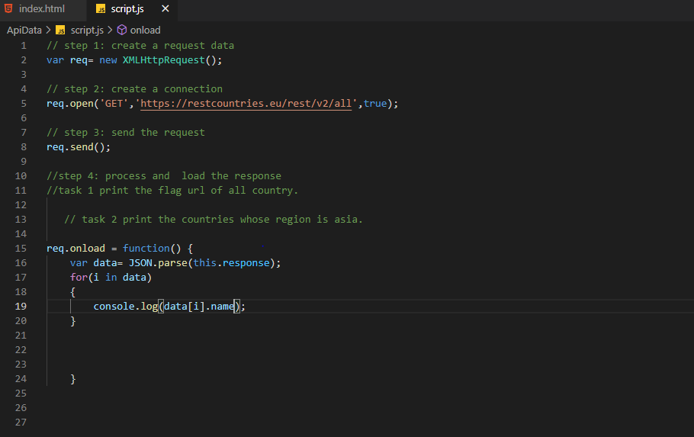

1. **Write a write up on Difference between copy by value and copy by reference.**

**Copy by value**

In a primitive data-type when a variable is assigned a value we can imagine that a box is created in the memory. This box has a sticker attached to it i.e. the variable name. Inside the box the value assigned to the variable is stored.

**Copy by reference**

In case of a non-primitive data-type the values are not directly copied. When a non-primitive data-type is assigned a value a box is created with a sticker of the name of the data-type. However, the values it is assigned is not stored directly in the box. The language itself assigns a different memory location to store the data. The address of this memory location is stored in the box created.

1. **How to copy by value a composite data type (array+objects).**

**There are 3 ways to copy by value for composite data types.**

1. **Using the spread (...) operator**
2. **Using the Object.assign() method**
3. **Using the JSON.stringify() and JSON.parse() methods**

**For example :-**

**const person = {**

**firstName: 'John',**

**lastName: 'Doe'**

**};**

**// using spread ...**

**let p1 = {**

**...person**

**};**

**// using Object.assign() method**

**let p2 = Object.assign({}, person);**

**// using JSON**

**let p3 = JSON.parse(JSON.stringify(person));**